General Characterization of Design Layouts and Ripper Configurations
Basic Layout Types:
- Redundant (14-25-36; 14-36-25)
  - Cutlet forces: push perpendicular to the bit profile.
  - Application: General purpose durable layout
- Forward Spiral (123456)
  - Cutlet forces: predominantly radial; compress the bit body (requires more torque)
  - Application: Surface bits and smaller rigs with limited WOB that want higher ROP; will require more torque.
- Reverse Spiral (165432)
  - Cutlet forces: predominantly axial (requires more WOB)
  - Application: Curve and laterals for higher overall ROP because of increased tool face control.

Additional Layouts:
- 6-3 (can be applied to any bit)
  - Makes any design more aggressive, but at the cost of being more vulnerable at low in/rev (effectively a three bladed bit).
- F-Type (4 variants)
  - Similar cutlets and aggressiveness of a 6-3, but all blades are equally exposed (more durable than a 6-3 at low in/rev)
  - A 6-blade F-Type bit is approximately equivalent to running a 5-bladed bit.
- F-type where Sec. blade patterns have a radial shift (infinite variants).
  - These designs are employed to make an F-Type bit more durable.
- Dragon (where trailing back-up cutters have their own blades)
  - These back-up positions do not pack off and slow ROP.
- Mixed Cutlet Type (one variant currently known)
  - This design employs all three cutlet shapes in one layout (Forward, Reverse, Redundant).

Cutter Configurations:
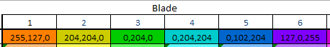
- C0 = Full Round PDC’s
- C1: Ripper cutters on secondary blades (No rippers in the cone)
- C2: Alternate Ripper cutters on primary blades

Basic Layout Types and Ripper Configurations:
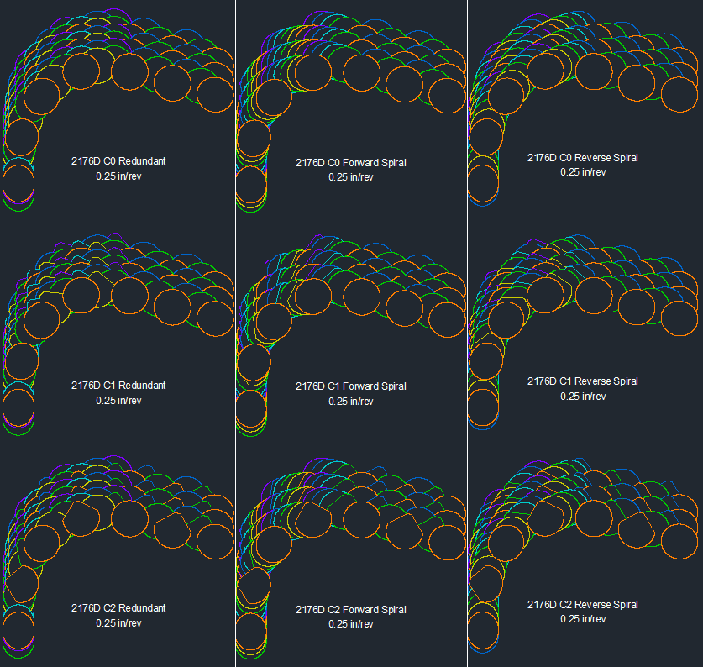
Note: all three of these designs would be more aggressive than a bit with full round cutters in every position.
Note: depending on the design of the bit C1 or C2 could have more rippers in the layout. It would need to reviewed on a case-by-case basis.
Additional Layout Types and Ripper Configurations:
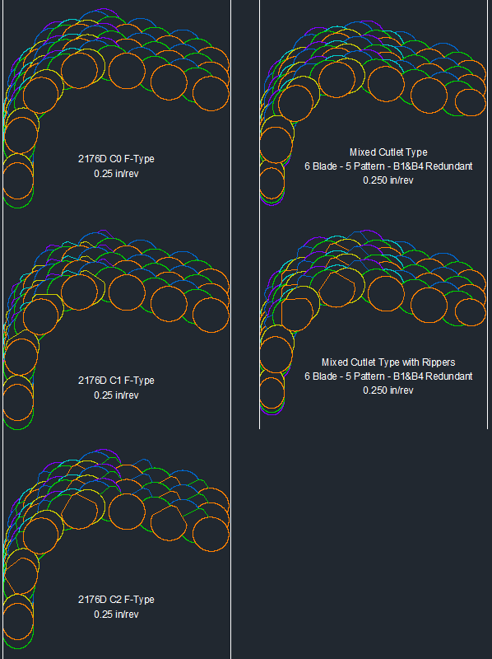

F-Type:
- The rippers of a C2 F-type bit engage more material than a C1 F-type.
  - The C2 F-Type is more aggressive than the C1 F-type.

Mixed Cutlet Type:
- This is an aggressive design similar in nature to the F-type’s aggressiveness but may be more efficient at dislodging and/or fracturing rock.
- The forces applied to the hole act in different directions with different magnitudes of engagement. (aka-simultaneously attack the hole with multiple methods)
